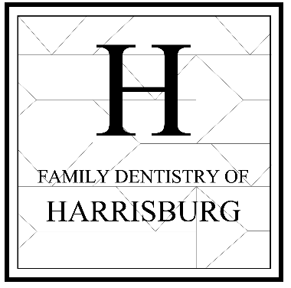
R. Barrows & Associates II PA
7230 Caldwell Road, Suite C1
Harrisburg, NC 28075
P: 704-456-7214 F:704-456-7683
WELCOME TO OUR PRACTICE!
Thank you for trusting our team with your dental care! We pride ourselves in excellence and offer a full array of services for you and your whole family. Care can begin for your family from the age of 2 and up. You can be assured that our highly qualified staff as well as our advanced facility offer the finest care available. Personal care and attention to your case are always provided in abundance as we look forward to keeping you as a patient for years to come! We strive to make your time with us today a pleasant experience, so please let us know if you have any special requests!
For patients without insurance, full payment is due the day of treatment.
For patients with dental insurance, co-payments are required on day of treatment. Insurance companies do not guarantee payment to our dental office. Insurance companies reserve the right to change or alter benefits depending on the underwriting on your insurance plan. A dental insurance card is not a guarantee of benefits. All fees shown regarding insurance are an estimate. If the insurance company decides that a reduced payment is to be made, the remaining balance would then be the responsibility of the patient or guarantor of the account. Please be aware that some appointments may require a deposit. We will make you aware of such an instance should it apply.
*** Insurance Filing***
Alternate Benefit: This is when an insurance company decides to down grade a filling or crown. A resin filling (tooth-colored) to an amalgam filling (silver) or a tooth-colored crown to a silver crown. If an insurance company chooses to pay the alternate benefit you will be responsible for the difference. Please ask our front staff any questions for clarification about the alternate benefit.
Please understand that our office is appointment driven. When you reserve an appointment, trained personnel, time and dental equipment are set aside exclusively for you and your procedure. Missed appointments add cost to dental care when reserved facilities are left empty. If you cannot make an appointment you must give our office at least 24 hours of advance notice or a $50.00 broken appointment fee may be charged to your account and your ability to make future appoinments will be limited. We respect your time, be assured that we will make every effort to see you at your scheduled time and complete procedures in a timely manner.
We Thank you for respecting our office policies and procedures and look forward to helping you maintain your healthy smile!
_________________________________________________ ________________________________
Patient Signature Date

